**Ques.**  The government of India is proactively planning to dispatch Covid 19 kits which would have medicines, sanitizers & masks in the historic hot spots of the country. The kits would be delivered to the homes of the citizen who cannot afford them. You, the star analyst of health ministry, is tasked to find out:

* 1. How many such kits are needed?
  2. What is the budget the health ministry should get sanctioned from the national treasury?
  3. What is the approximate time required to complete this whole activity?

**Poverty Rate in India:**

According to Niti Aayog’s first Multidimensional Poverty Index (MPI) report released in November 2021, the National MPI score of India is 0.118. In Urban areas, the MPI score is 0.08 and rural it is 0.155.

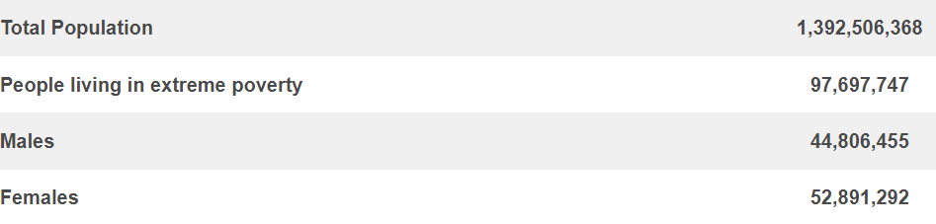Here are the Indian Poverty Statistics 2021, according to the World Poverty Clock:

Out of the entire population in India, 97.7 million people are living in poverty, all varying from new-born babies to senior citizens. Therefore, there are 97.7 million people across the country who won’t be able to afford the Covid19 Kit.

If the Government of India needs one Covid19 Kit per person, the government will need around 98 million Covid19 Kits.

The Covid Kit will consist of medicines, sanitizer and masks.

The kit will have 2 N-95 masks, 10 surgical masks, a 500ml bottle of sanitizer, and medicines for around a week.

According to the Centre of Disease Control and Prevention, the medications that should be taken for Covid-19 treatment are as follows:

1. PAXLOVID: PAXLOVID consists of 2 medicines: nirmatrelvir tablets and ritonavir tablets. The tablets are taken together 2 times each day for 5 days.
2. LAGEVRIO: LAGEVRIO tablets are taken 2 times each day for 5 days.

This shows that a person will need 10 nirmatrelvir tablets, 10 ritonavir tablets and 10 lagevrio tablets.

**Calculating the price for one Covid Kit:**

The price of two N-95 Mask in India: Rs. 500  
The price of ten Surgical Masks in India: Rs. 100  
The price of a bottle of Sanitizer in India: Rs. 165  
The price of 10 LAGEVRIO tablets: Rs. 500  
The price of 10 nirmatrelvir tablets: Rs. 100  
The price of 10 ritonavir tablets: Rs. 300

The cost for making one Covid-19 Kit will be approximately Rs. 1665. Considering the packaging and set of instructions, one kit would cost around Rs. 1800.

Since there are 97.7 million kits needed, the total cost for all kits will be around: Rs. 1758.6 million

**Transportation Charges in India:**

According to a survey in 2021, road transport in India is around 3.6 rupees per metric kilometre.

India is said to have a land frontier of 15,200 km.

Therefore, the total transportation cost will be around Rs. 54,720.

Adding up all the other charges and the wages of the workers, the health ministry should get around Rs. 1760 million sanctioned from the national treasury.

The steps that will be followed for the above activity:

1. The Health Ministry will request a sanction from the treasury. This will take about 2 days.
2. The treasury will approve the sanction. This will take about a week.
3. The raw materials and other things will be arranged, along with labour. This will take about a week.
4. The Covid Kits will be prepared by the Health Ministry. This will take about two weeks.
5. The kits will be transported throughout India. This will take about two weeks.

The total time the government requires to undergo this activity is around 7 weeks, including some buffer time.